Home Component (Screenshot1)

Carousels(Image 1)

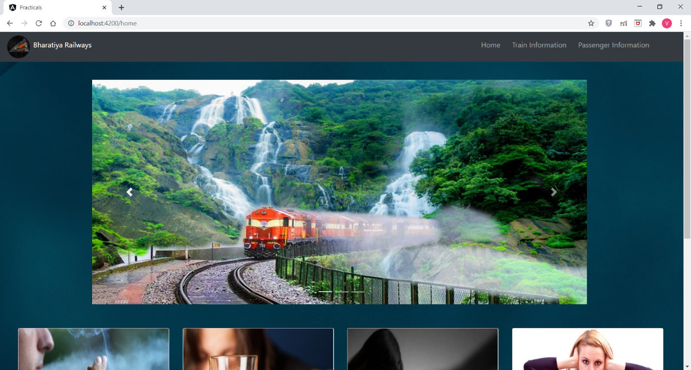

Home Component (Screenshot2)

Carousal(Image2) in Home Component

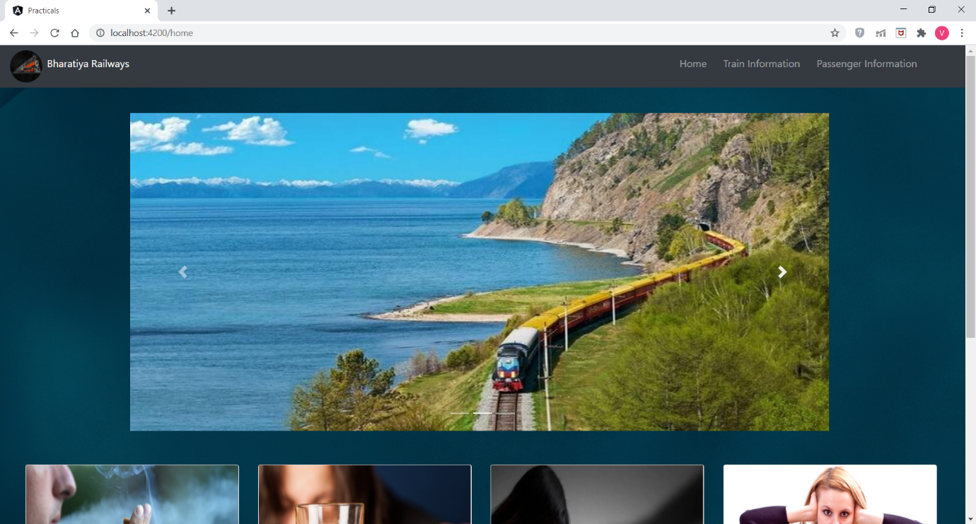

Home Component (Screenshot3)

Carousal(Image3) in Home Component

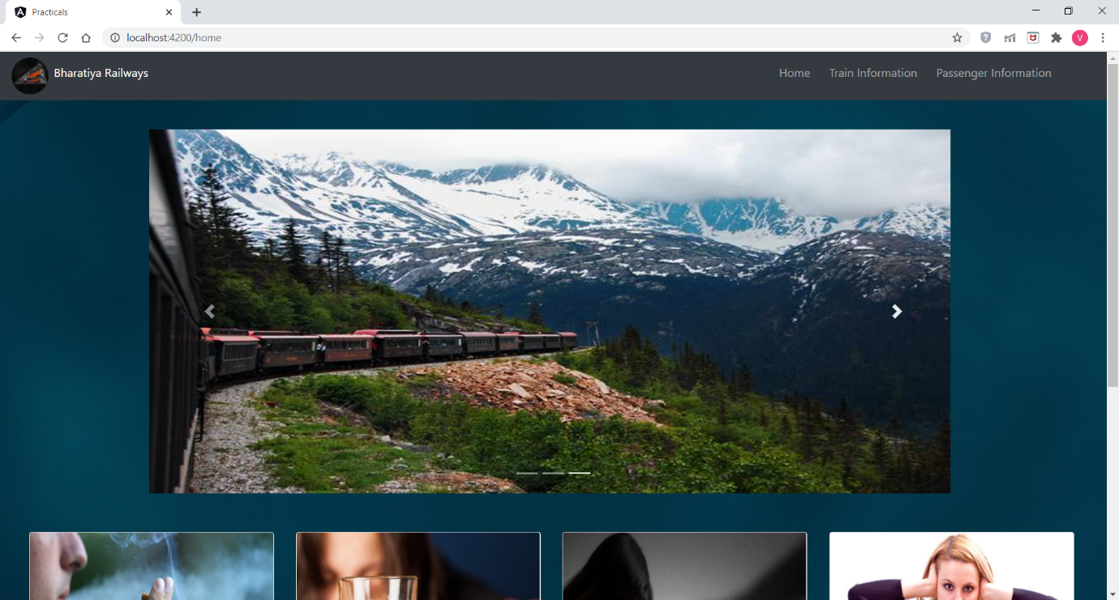

Home Component (Screenshot4)

Forbidden Acts In Trains in Home Component

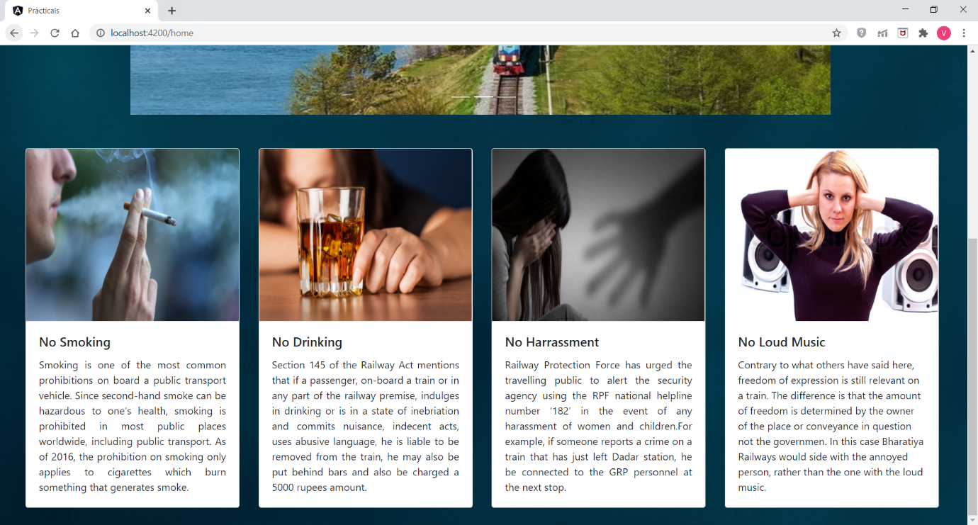

Train-Information Component(Screenshot1)

All the train details are displayed

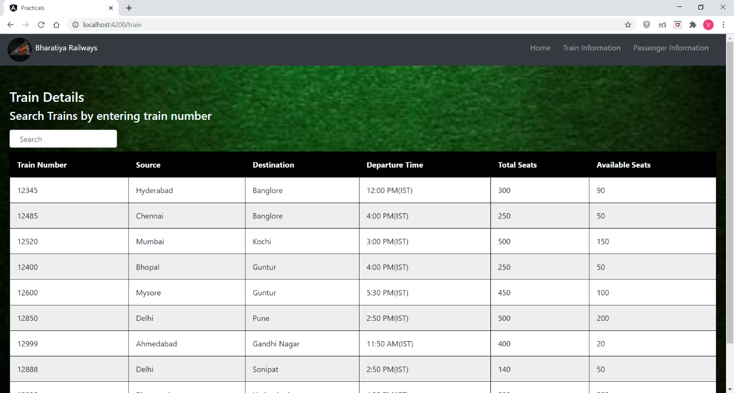

Train-Information Component(Screenshot2)

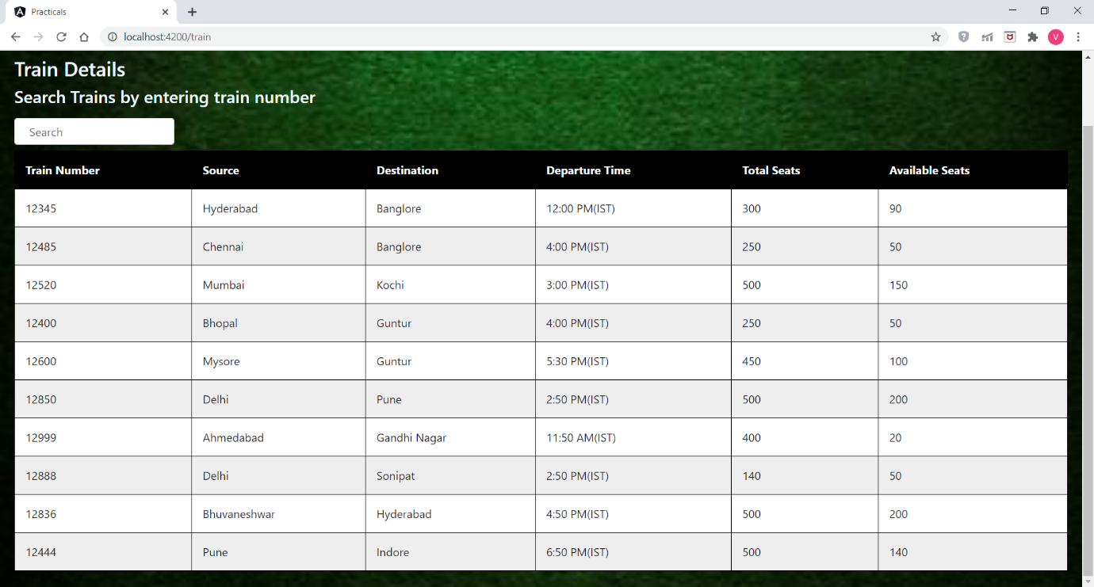

Train-Information Component(Screenshot3)

Filtering table based on input from edit box

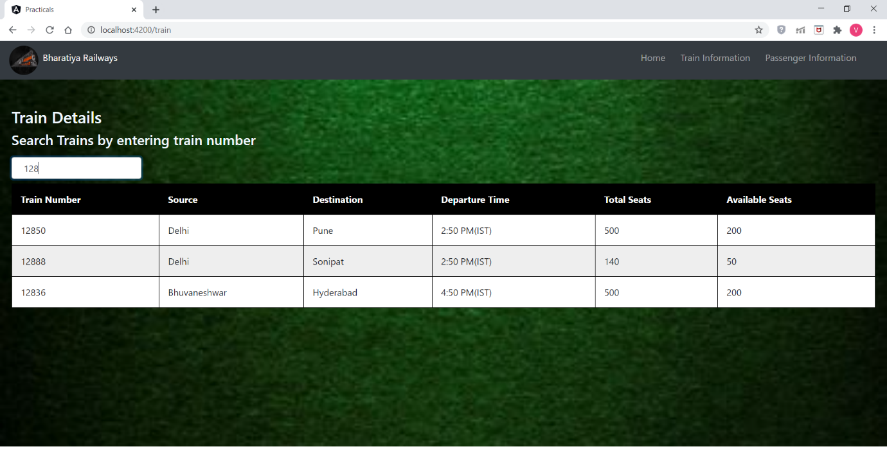

Train-Information Component(Screenshot4)

Filtering table based on input from edit box

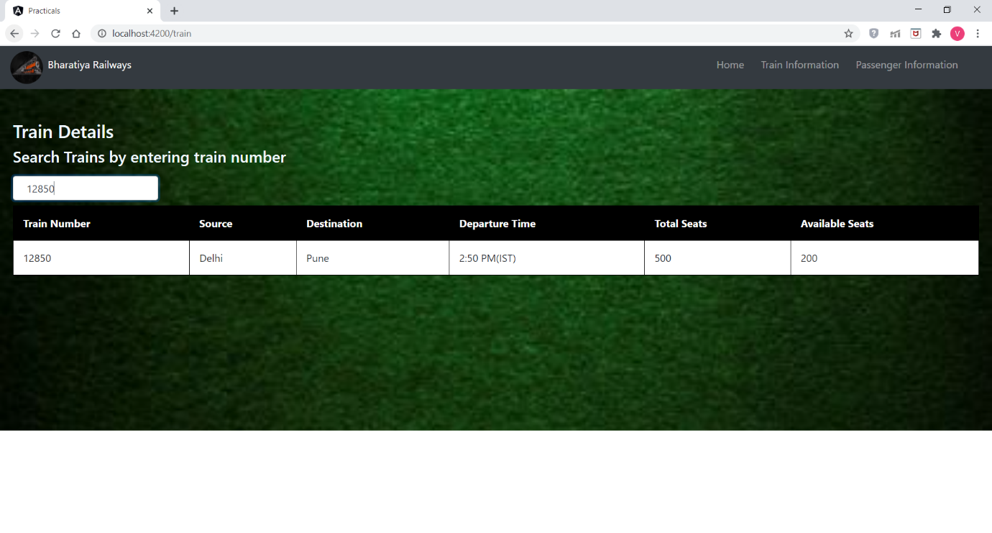

Passenger Component(Screenshot1)

All the passenger details are displayed

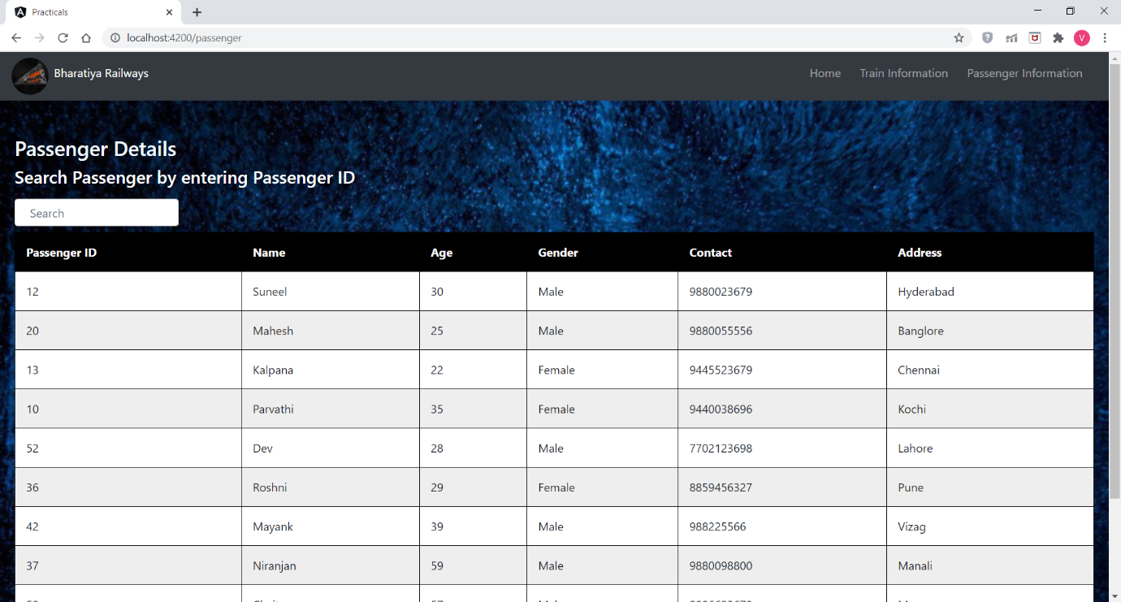

Passenger Component(Screenshot2)

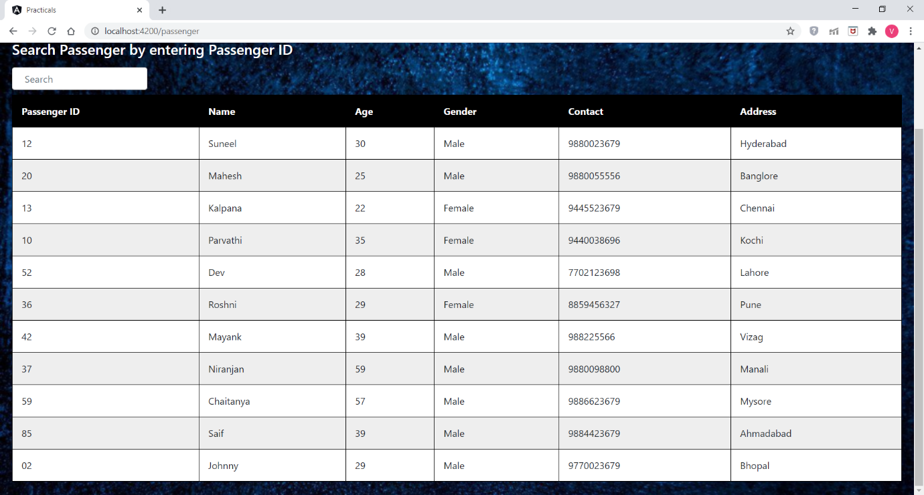

Passenger Component(Screenshot3)

Filtering passenger details based on passenger ID

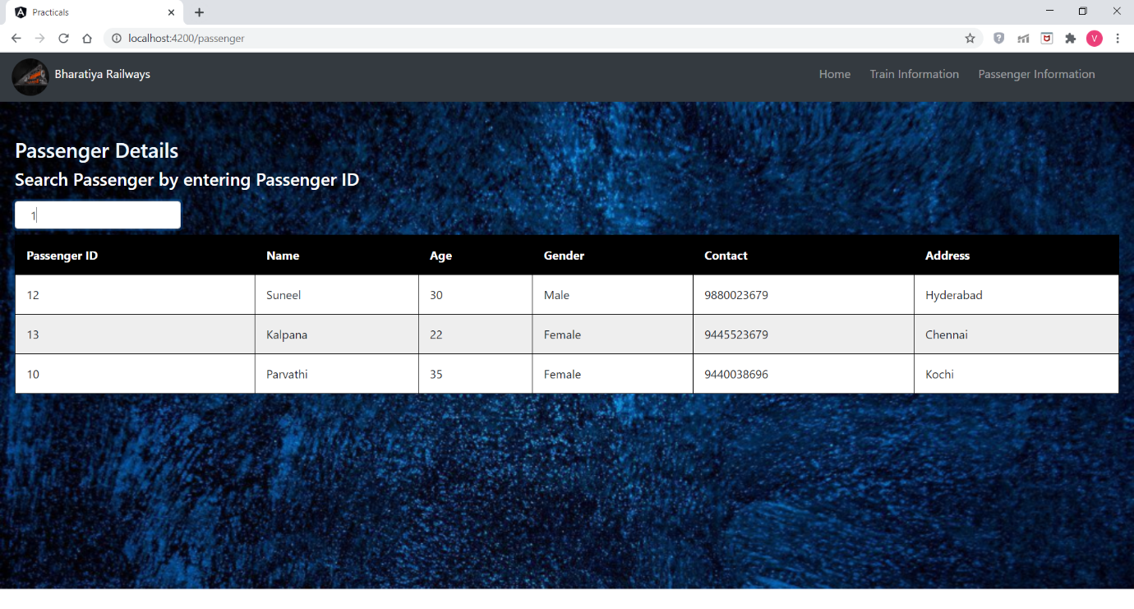

Passenger Component(Screenshot4)

Filtering passenger details based on passenger ID

